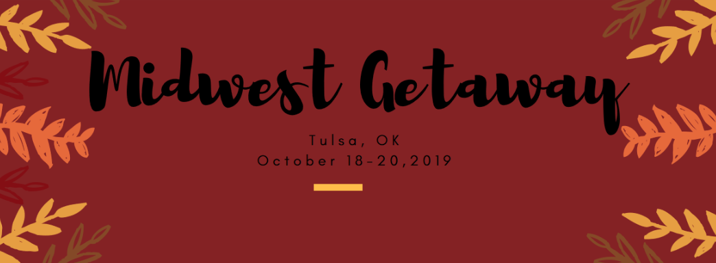
REGISTRATION FORM
Email: positivelybalancedeh@gmail.com

PERSONAL INFORMATION
Full Name: Age Group: ☐20’s ☐30’s ☐40’s ☐50’s ☐60’s ☐70+
Home Address:
City:
State/Prov:
Country:
Telephone: Email:
Emergency contact name:
Telephone:

Please mention any relevant medical history (food allergies, heart condition, blood pressure, arthritis, back or neck problems, etc

Anything else we should be aware of?

Lodging:
We are renting a location to stay in all together. Prices will vary upon option taken. First come first serve, if you choose one that is taken, I will email you ASAP and tell you what is still available:
Rooms: Rates are per person
Upstairs
Bedroom 1: 2 queens $55/night one queen taken, 1 remain
Bedroom 2: 2 queens $55/night
Bedroom 3: 1 king $ 60/night Taken
Downstairs
Bedroom 4: 1 queen $60/night taken
Flat room: 4 queens w optional 4 twins + living room area $50/night 4 bed taken, 2 remain
I will let you know if you have selected an option already filled and respond with what is available.
Any dietary restrictions to indicate:

FRIDAY dinner, SATURDAY Breakfast, Lunch & SUNDAY Breakfast: PROVIDED BY Positively Balanced
Please indicate your Friday LUNCH preference:
- ☐Chicken Meal ☐Ground Beef Meal
PAYMENT INFORMATION: Includes meals, snacks, materials, classes, seminars and amenities.
Package options:
Commuter guest pricing $250 ($50 Non refundable deposit due with form)
House guest pricing $225 ($50 Non refundable deposit due with form)
Payment method: ☐Paypal ☐Check (address given after you email form. Spot saved for 10 days and if check not received, spot goes to next in line)
FULL PAYMENT AMOUNT DUE September 10th.
Cancellation Policy: $50 Non refundable deposit due with form. Full payment paid is refunded at discretion of founder.
Photo/Videos: We will be taking photos and video during the Midwest Getaway. By signing this registration form, you are agreeing to allow us to use any photos or video that you may be a part of, for promotional or marketing purposes.
Disclaimer and other policies: I understand that I am participating in all classes entirely at my own risk and any loss, damage, injury or other mishaps will not be the responsibility of the class organizer or teacher. (If you are in doubt as to the suitability of the class to your medical condition, please consult your doctor.)

Participant signature:
Date:

This getaway is sponsored by Positively Balanced LLC
positivelybalancedh@gmail.com
LIABILITY WAIVER

Professional Disclaimer Waiver
To the best of my knowledge I am in good physical and mental condition and am capable of participating in this Midwest Getaway Event, workshops and classes. I am not aware of any physical or mental illness or injury that prevents me from participating in this event. _______

I,_______________________, understand that the Midwest Getaway is not a substitute for medical attention, examination, diagnosis or treatment. I know the importance of consulting a physician prior to beginning any physically active program, including Midwest Getaway. I recognize that it is my responsibility to notify my instructor of any illness or injury before every Midwest Getaway class. I will not perform any postures or participate in Midwest Getaway classes to the extent of strain or pain.
I accept that neither the instructor, nor the hosting facility is liable for any injury, or damages, to person or property, resulting from the taking of the class.
This Waiver and Release of Liability form shall remain in effective until it is revoked in writing by the client.
Those under 18 years of age must have this form signed by a parent or guardian.

____________________________________________ ________________________
Signature Date

